

Java Task Book 1

|  |
| --- |
| Name |
|  |



! Complete all activities in this workbook by including screenshots of your code and working programs where requested.

! To use this workbook, you will need to use the PPT/PDF book ‘Java for Beginners’.

! Save each program created and paste your code/outputs into this booklet

! Remember, when you get stuck, C3B4ME and use the support links provided.

This booklet provides a comprehensive set of problems for you to solve using the Java programming language. It is separated into levels, each of which focus on a different aspect of generic programming constructs. They will gradually get more complex towards the end and will likely require some independent research to complete. Some recommended websites to use are below:

* Useful for syntax help: <https://www.w3schools.com/java/>
* Tutorials and examples: <https://www.programiz.com/java-programming>
* Nice tutorials covering the full Java spec: <https://www.javatpoint.com/java-tutorial>
* Nice tutorials covering the full Java spec: <https://www.tutorialspoint.com/java/index.htm>
* Beginners Tutorial: <https://www.guru99.com/java-tutorial.html>
* Glossary: <https://stackify.com/java-glossary/>

The levels in these workbooks are:

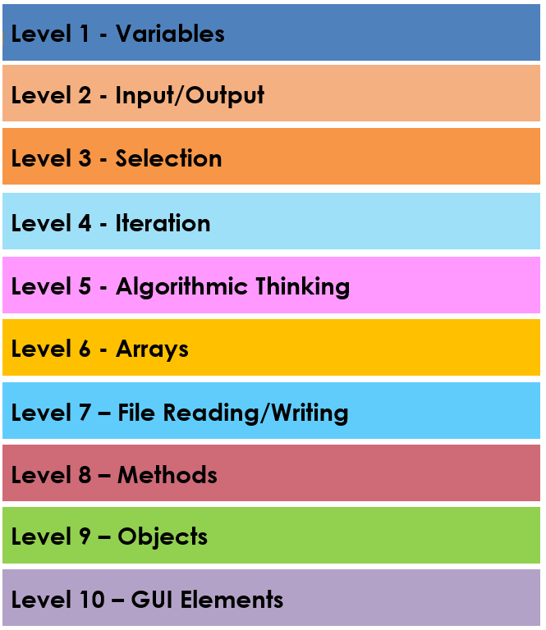

We will deal with the first 6 levels in this workbook

Contents

GLOSSARY 5

Level 1: Variables (easy) 7

Task 1C – Postman Pat 9

Task 1D – All about me 11

Task 1F Calculations 13

Level 2: Input & Output (easy) 15

Task 2A Greet Me 15

Task 2D Number Time 17

Task 2I Times Tables 19

Task 2 Shout and Whisper 21

Task 2L Aplha Omega 23

Level 3: Selection (easy) 25

Task 3A Temp Check 25

Task 3B Super Hero 27

Task 3D Speeding Fine 29

Task 3E GTA Checker 31

Task 3F Find my teacher 33

Task 3I Coding system selector 35

Task 3J Brickman 37

Task 3K Pay Calc 39

Task 3L Simpsons Checker 41

Task 3M Santa Claus 43

Task 3N Odd or Even 45

Task 3Q Cinema Age Checker 47

Task 3T Number Selector 49

Task 3V Quiz Master 51

Task 3W Case Calc 54

Level 4: Iteration (easy-medium) 57

Task 4 – Repeat after me 57

Task 4B Spellman 59

Task 4C Alphabet Loop 61

Task 4D Doubling Score 64

Task 4E Green Bottles 66

Task 4F Factors 68

Task 4G Loops with numbers 70

Task 4H Block Maker 72

Task 4I Word Pyramid 74

Task 4J Plus Me 76

Task 4K Word Size Checker 78

Task 4L While Calc 80

Task 4M Block Maker 2 83

Level 5: Algorithmic Thinking (medium) 85

Task 5B Biggest Number 85

Task 5C Maths Trainer 87

Task 5E Lock Picker 89

Task 5F Season Checker 91

Task 5M Name Mixer 93

Task 5R InCommon 95

Level 6: Arrays 97

Task 6A Little Boxes 97

Task 6A Little Boxes 99

Task 6C Number Hunt 101

Task 6D Backward Boxes 103

Task 6F Array Averages 105

Task 6G Array Min 107

Task 6A Little Boxes 109

Task 6N Letter Sorter 111

Task 6O Super Sorter 113

113

GLOSSARY

Add in any key terminology and the definitions as you work through the booklet.

|  |  |
| --- | --- |
| TERM | DESCRIPTION |
| **Generic Programming Constructs** | |
| Algorithm |  |
| Decomposition |  |
| Pattern Recognition |  |
| Abstraction |  |
| Variable |  |
| String |  |
| Integer |  |
| Double |  |
| Function |  |
| Built-in function |  |
| Truncate |  |
| Modulus |  |
| Parameter |  |
| Selection |  |
| Condition |  |
| Flow Chart |  |
| Fixed Loop |  |
| Conditional Loop |  |
| Array |  |
| 1D List |  |
| 2D List |  |
| Elements |  |
| Append |  |
|  |  |
| **Java Principles** | |
|  |  |
| Pop( ) |  |
| Variable |  |
| Method |  |
| Type + Name |  |
| Identifier |  |
| Signature |  |
| Block of Code |  |
| Class |  |
| Instance |  |
| new Keyword |  |
| Constructor |  |
| new + Constructor |  |
| . (Dot operator) |  |
| Object-Oriented Paradigm |  |
| Object |  |
| Field |  |
| Side Effect |  |
| Reference |  |
| Primitive Type |  |
| State |  |
| Expression |  |
| Statement |  |
| Declaration |  |
| Compiler |  |
|  |  |
|  |  |

Level 1: Variables (easy)

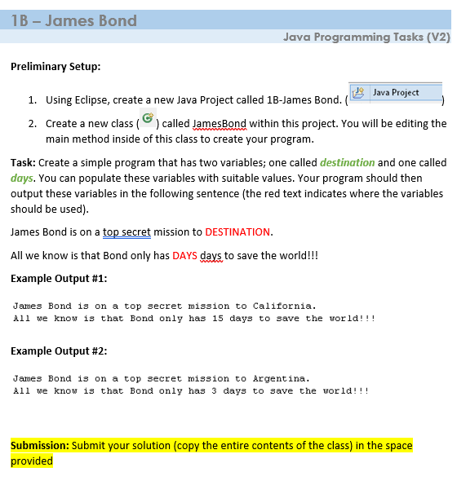

|  |
| --- |
| **Notes:**  **SUBMISSION: Paste your code into the next row along with the ‘**output’ **as a printscreen/screenshot** |
| **CODE**  (this is the actual program code including the main method) |
| **OUTPUT**  (this is the result of running your code) |
| **Reflections**  *What problems did you have in producing this solution?*  *How could you improve for next time?*  *Overall, how difficult was it? (fill the boxes with colour per the example below)*  EASY VERY DIFFICULT   |  |  |  |  |  | | --- | --- | --- | --- | --- | | **1** | **2** | **3** | **4** | **5** | |  |  |  |  |  | |

Task 1C – Postman Pat

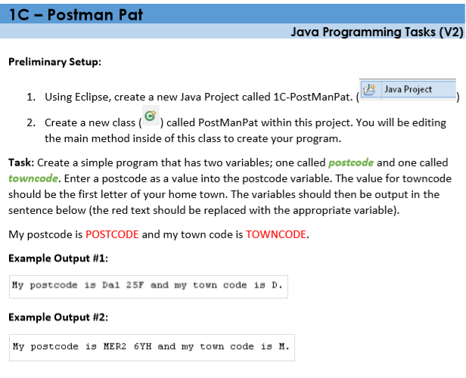

|  |
| --- |
| **Notes:**  **SUBMISSION: Paste your code into the next row along with the ‘**output’ **as a printscreen/screenshot** |
| **CODE**  (this is the actual program code including the main method) |
| **OUTPUT**  (this is the result of running your code) |
| **Reflections**  *What problems did you have in producing this solution?*  *How could you improve for next time?*  *Overall, how difficult was it? (fill the boxes with colour)*  EASY VERY DIFFICULT   |  |  |  |  |  | | --- | --- | --- | --- | --- | | **1** | **2** | **3** | **4** | **5** | |  |  |  |  |  | |

Task 1D – All about me

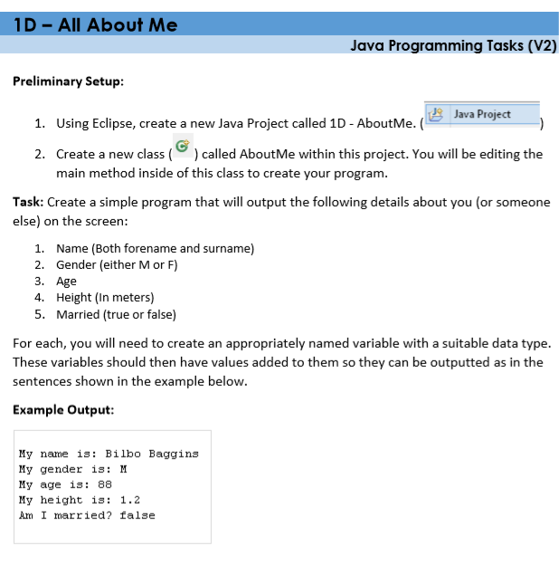

|  |
| --- |
| **Notes:**  **SUBMISSION: Paste your code into the next row along with the ‘**output’ **as a printscreen/screenshot** |
| **CODE**  (this is the actual program code including the main method) |
| **OUTPUT**  (this is the result of running your code) |
| **Reflections**  *What problems did you have in producing this solution?*  *How could you improve for next time?*  *Overall, how difficult was it? (fill the boxes with colour)*  EASY VERY DIFFICULT   |  |  |  |  |  | | --- | --- | --- | --- | --- | | **1** | **2** | **3** | **4** | **5** | |  |  |  |  |  | |

Task 1F Calculations

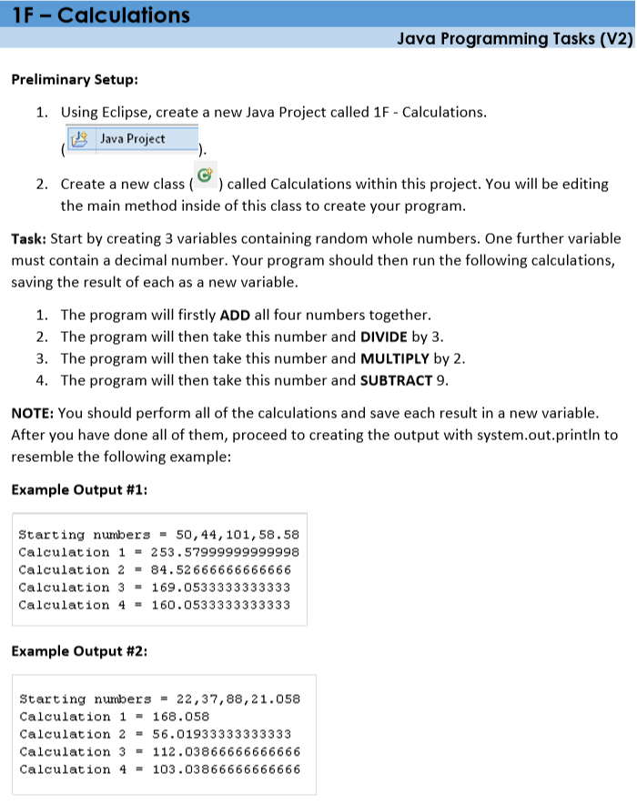

|  |
| --- |
| **Notes:**  **SUBMISSION: Paste your code into the next row along with the ‘**output’ **as a printscreen/screenshot** |
| **CODE**  (this is the actual program code including the main method) |
| **OUTPUT**  (this is the result of running your code) |
| **Reflections**  *What problems did you have in producing this solution?*  *How could you improve for next time?*  *Overall, how difficult was it? (fill the boxes with colour)*  EASY VERY DIFFICULT   |  |  |  |  |  | | --- | --- | --- | --- | --- | | **1** | **2** | **3** | **4** | **5** | |  |  |  |  |  | |

Level 2: Input & Output (easy)

Task 2A Greet Me

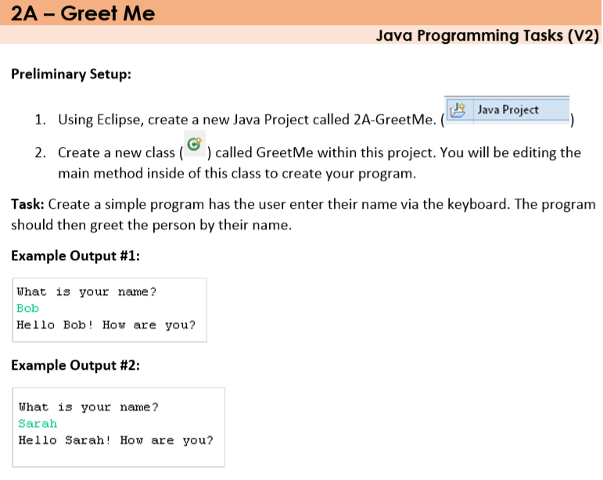

|  |
| --- |
| **Notes:**  **SUBMISSION: Paste your code into the next row along with the ‘**output’ **as a printscreen/screenshot** |
| **CODE**  (this is the actual program code including the main method) |
| **OUTPUT**  (this is the result of running your code) |
| **Reflections**  *What problems did you have in producing this solution?*  *How could you improve for next time?*  *Overall, how difficult was it? (fill the boxes with colour)*  EASY VERY DIFFICULT   |  |  |  |  |  | | --- | --- | --- | --- | --- | | **1** | **2** | **3** | **4** | **5** | |  |  |  |  |  | |

Task 2D Number Time

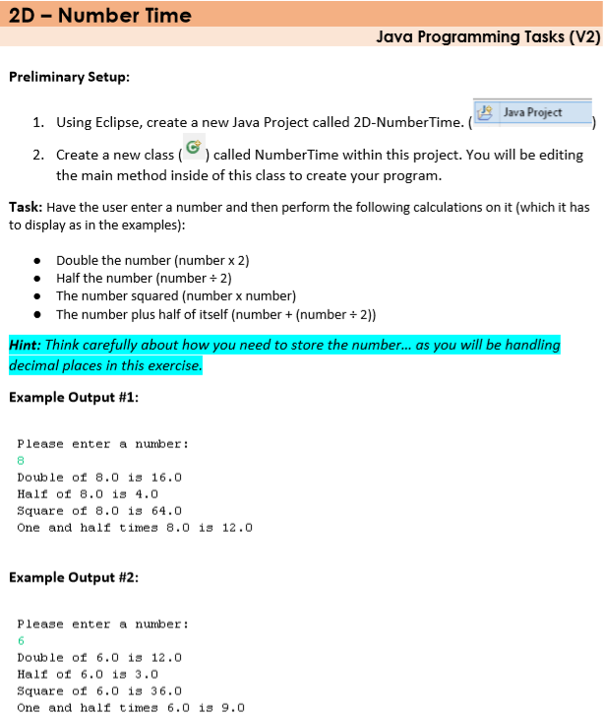

|  |
| --- |
| **Notes:**  **SUBMISSION: Paste your code into the next row along with the ‘**output’ **as a printscreen/screenshot** |
| **CODE**  (this is the actual program code including the main method) |
| **OUTPUT**  (this is the result of running your code) |
| **Reflections**  *What problems did you have in producing this solution?*  *How could you improve for next time?*  *Overall, how difficult was it? (fill the boxes with colour)*  EASY VERY DIFFICULT   |  |  |  |  |  | | --- | --- | --- | --- | --- | | **1** | **2** | **3** | **4** | **5** | |  |  |  |  |  | |

Task 2I Times Tables

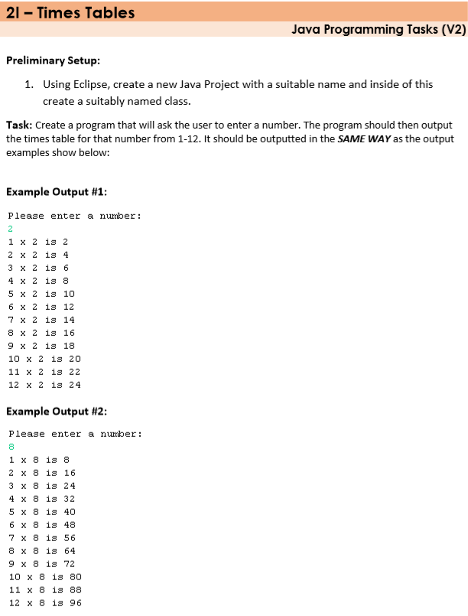

|  |
| --- |
| **Notes:**  **SUBMISSION: Paste your code into the next row along with the ‘**output’ **as a printscreen/screenshot** |
| **CODE**  (this is the actual program code including the main method) |
| **OUTPUT**  (this is the result of running your code) |
| **Reflections**  *What problems did you have in producing this solution?*  *How could you improve for next time?*  *Overall, how difficult was it? (fill the boxes with colour)*  EASY VERY DIFFICULT   |  |  |  |  |  | | --- | --- | --- | --- | --- | | **1** | **2** | **3** | **4** | **5** | |  |  |  |  |  | |

Task 2 Shout and Whisper

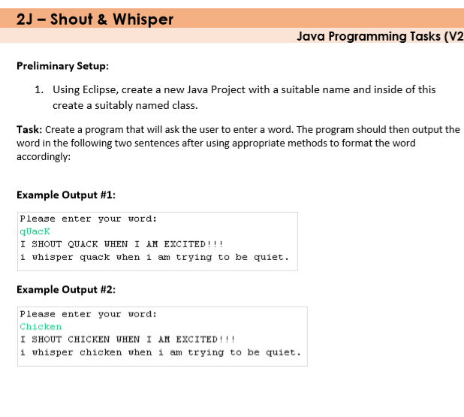

|  |
| --- |
| **Notes:**  **SUBMISSION: Paste your code into the next row along with the ‘**output’ **as a printscreen/screenshot** |
| **CODE**  (this is the actual program code including the main method) |
| **OUTPUT**  (this is the result of running your code) |
| **Reflections**  *What problems did you have in producing this solution?*  *How could you improve for next time?*  *Overall, how difficult was it? (fill the boxes with colour)*  EASY VERY DIFFICULT   |  |  |  |  |  | | --- | --- | --- | --- | --- | | **1** | **2** | **3** | **4** | **5** | |  |  |  |  |  | |

Task 2L Aplha Omega

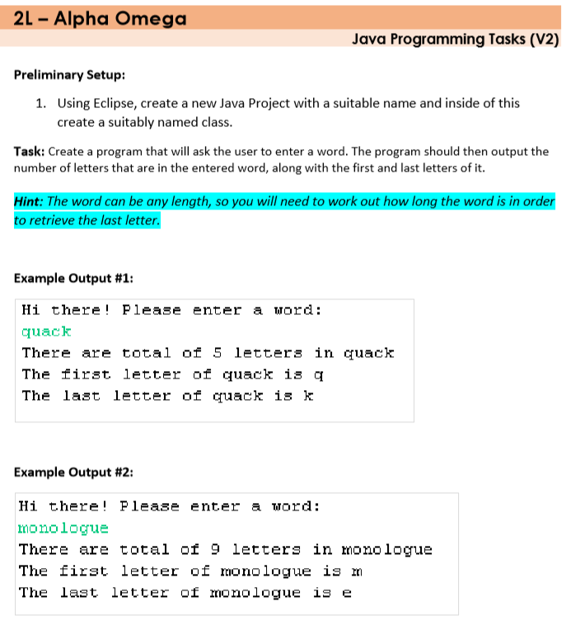

|  |
| --- |
| **Notes:**  **SUBMISSION: Paste your code into the next row along with the ‘**output’ **as a printscreen/screenshot** |
| **CODE**  (this is the actual program code including the main method) |
| **OUTPUT**  (this is the result of running your code) |
| **Reflections**  *What problems did you have in producing this solution?*  *How could you improve for next time?*  *Overall, how difficult was it? (fill the boxes with colour)*  EASY VERY DIFFICULT   |  |  |  |  |  | | --- | --- | --- | --- | --- | | **1** | **2** | **3** | **4** | **5** | |  |  |  |  |  | |

Level 3: Selection (easy)

Task 3A Temp Check

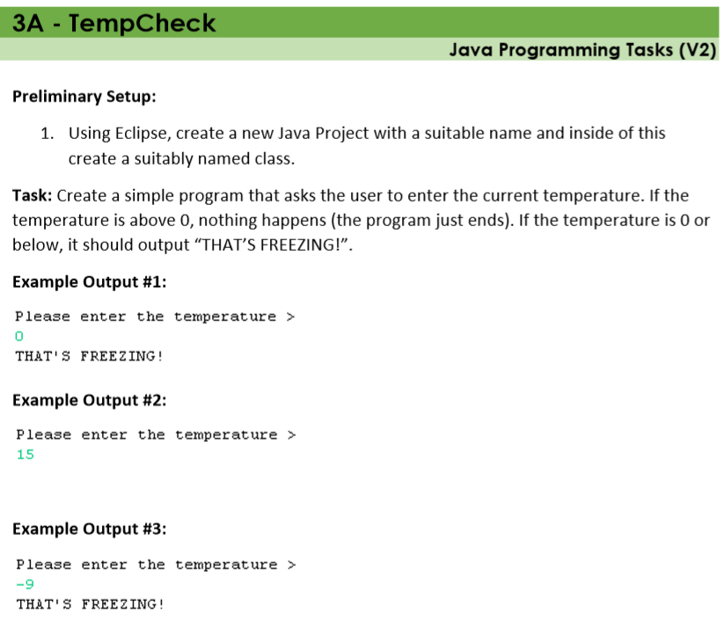

|  |
| --- |
| **Notes:**  **SUBMISSION: Paste your code into the next row along with the ‘**output’ **as a printscreen/screenshot** |
| **CODE**  (this is the actual program code including the main method) |
| **OUTPUT**  (this is the result of running your code) |
| **Reflections**  *What problems did you have in producing this solution?*  *How could you improve for next time?*  *Overall, how difficult was it? (fill the boxes with colour)*  EASY VERY DIFFICULT   |  |  |  |  |  | | --- | --- | --- | --- | --- | | **1** | **2** | **3** | **4** | **5** | |  |  |  |  |  | |

Task 3B Super Hero

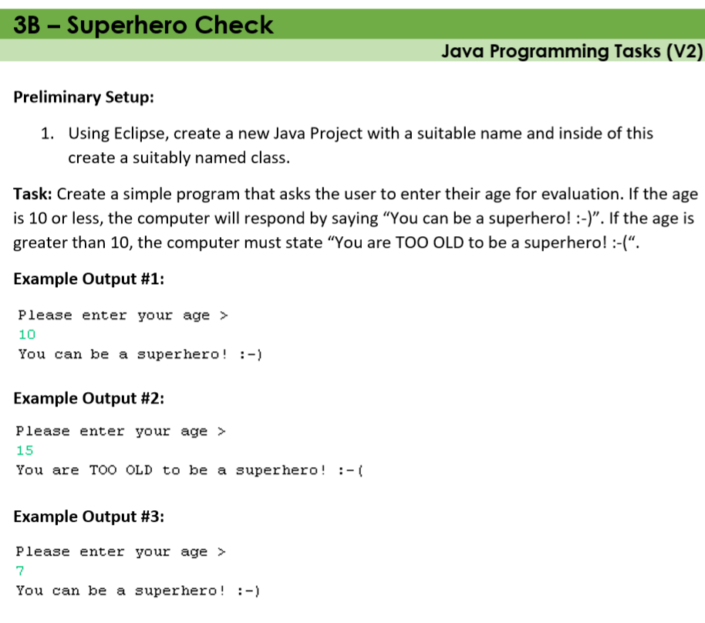

|  |
| --- |
| **Notes:**  **SUBMISSION: Paste your code into the next row along with the ‘**output’ **as a printscreen/screenshot** |
| **CODE**  (this is the actual program code including the main method) |
| **OUTPUT**  (this is the result of running your code) |
| **Reflections**  *What problems did you have in producing this solution?*  *How could you improve for next time?*  *Overall, how difficult was it? (fill the boxes with colour)*  EASY VERY DIFFICULT   |  |  |  |  |  | | --- | --- | --- | --- | --- | | **1** | **2** | **3** | **4** | **5** | |  |  |  |  |  | |

Task 3D Speeding Fine

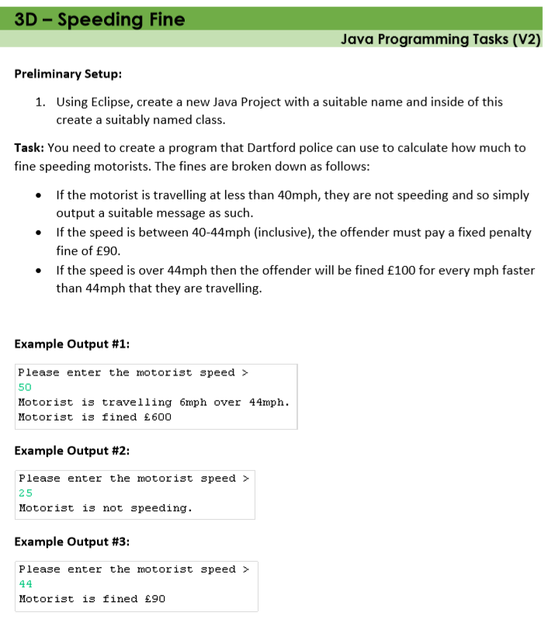

|  |
| --- |
| **Notes:**  **SUBMISSION: Paste your code into the next row along with the ‘**output’ **as a printscreen/screenshot** |
| **CODE**  (this is the actual program code including the main method) |
| **OUTPUT**  (this is the result of running your code) |
| **Reflections**  *What problems did you have in producing this solution?*  *How could you improve for next time?*  *Overall, how difficult was it? (fill the boxes with colour)*  EASY VERY DIFFICULT   |  |  |  |  |  | | --- | --- | --- | --- | --- | | **1** | **2** | **3** | **4** | **5** | |  |  |  |  |  | |

Task 3E GTA Checker

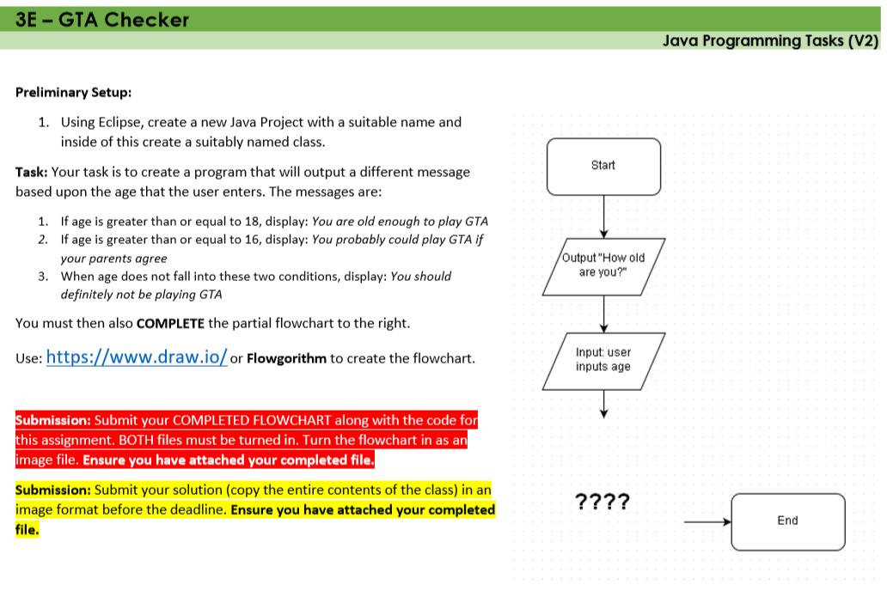

**NOTE: For this solution, a flowchart must also be completed within flowgorithm or your own choice of tool**

|  |
| --- |
| **Notes:**  **SUBMISSION: Paste your code into the next row along with the ‘**output’ **as a printscreen/screenshot** |
| **CODE**  (this is the actual program code including the main method) |
| **OUTPUT**  (this is the result of running your code)  **Flowchart** |
| **Reflections**  *What problems did you have in producing this solution?*  *How could you improve for next time?*  *Overall, how difficult was it? (fill the boxes with colour)*  EASY VERY DIFFICULT   |  |  |  |  |  | | --- | --- | --- | --- | --- | | **1** | **2** | **3** | **4** | **5** | |  |  |  |  |  | |

Task 3F Find my teacher

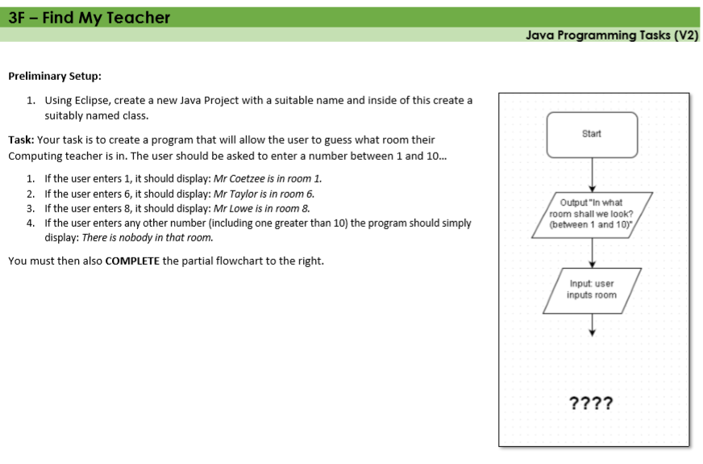

**NOTE: For this solution, a flowchart must also be completed within flowgorithm or your own choice of tool**

|  |
| --- |
| **Notes:**  **SUBMISSION: Paste your code into the next row along with the ‘**output’ **as a printscreen/screenshot** |
| **CODE**  (this is the actual program code including the main method) |
| **OUTPUT**  (this is the result of running your code)  **Flowchart** |
| **Reflections**  *What problems did you have in producing this solution?*  *How could you improve for next time?*  *Overall, how difficult was it? (fill the boxes with colour)*  EASY VERY DIFFICULT   |  |  |  |  |  | | --- | --- | --- | --- | --- | | **1** | **2** | **3** | **4** | **5** | |  |  |  |  |  | |

Task 3I Coding system selector

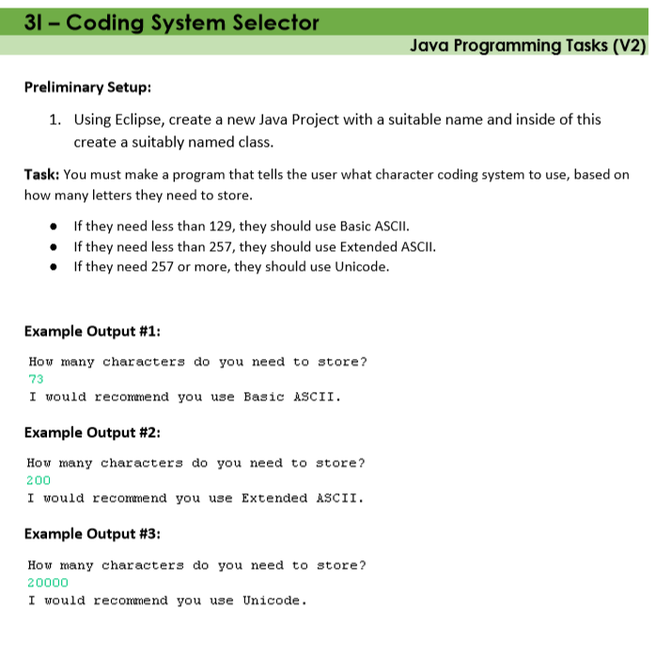

|  |
| --- |
| **Notes:**  **SUBMISSION: Paste your code into the next row along with the ‘**output’ **as a printscreen/screenshot** |
| **CODE**  (this is the actual program code including the main method) |
| **OUTPUT**  (this is the result of running your code) |
| **Reflections**  *What problems did you have in producing this solution?*  *How could you improve for next time?*  *Overall, how difficult was it? (fill the boxes with colour)*  EASY VERY DIFFICULT   |  |  |  |  |  | | --- | --- | --- | --- | --- | | **1** | **2** | **3** | **4** | **5** | |  |  |  |  |  | |

Task 3J Brickman

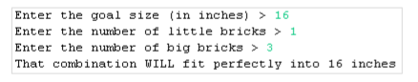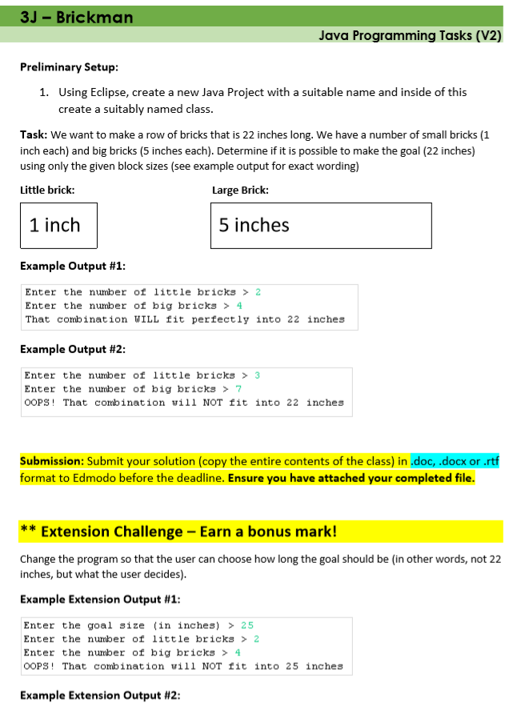

|  |
| --- |
| **Notes:**  **SUBMISSION: Paste your code into the next row along with the ‘**output’ **as a printscreen/screenshot** |
| **CODE**  (this is the actual program code including the main method) |
| **OUTPUT**  (this is the result of running your code) |
| **Reflections**  *What problems did you have in producing this solution?*  *How could you improve for next time?*  *Overall, how difficult was it? (fill the boxes with colour)*  EASY VERY DIFFICULT   |  |  |  |  |  | | --- | --- | --- | --- | --- | | **1** | **2** | **3** | **4** | **5** | |  |  |  |  |  | |

Task 3K Pay Calc

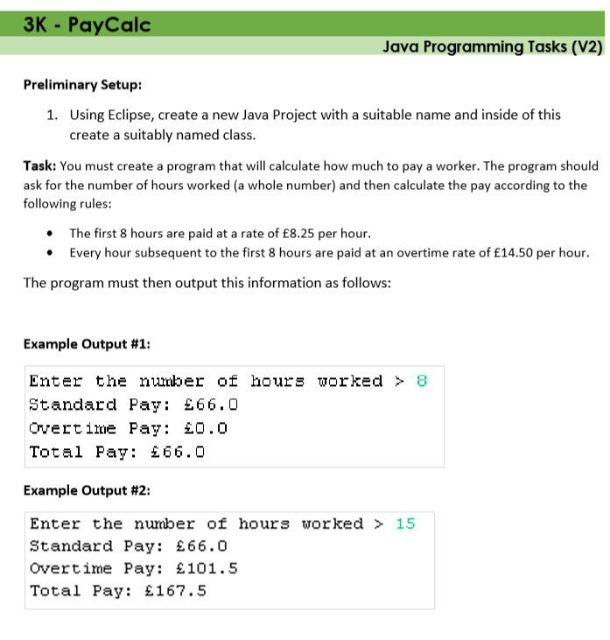

|  |
| --- |
| **Notes:**  **SUBMISSION: Paste your code into the next row along with the ‘**output’ **as a printscreen/screenshot** |
| **CODE**  (this is the actual program code including the main method) |
| **OUTPUT**  (this is the result of running your code) |
| **Reflections**  *What problems did you have in producing this solution?*  *How could you improve for next time?*  *Overall, how difficult was it? (fill the boxes with colour)*  EASY VERY DIFFICULT   |  |  |  |  |  | | --- | --- | --- | --- | --- | | **1** | **2** | **3** | **4** | **5** | |  |  |  |  |  | |

Task 3L Simpsons Checker

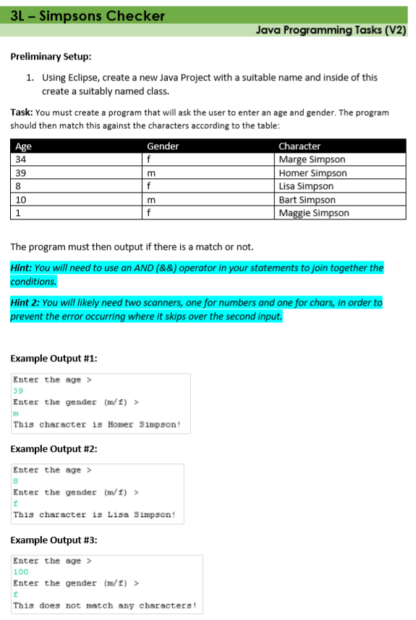

|  |
| --- |
| **Notes:**  **SUBMISSION: Paste your code into the next row along with the ‘**output’ **as a printscreen/screenshot** |
| **CODE**  (this is the actual program code including the main method) |
| **OUTPUT**  (this is the result of running your code) |
| **Reflections**  *What problems did you have in producing this solution?*  *How could you improve for next time?*  *Overall, how difficult was it? (fill the boxes with colour)*  EASY VERY DIFFICULT   |  |  |  |  |  | | --- | --- | --- | --- | --- | | **1** | **2** | **3** | **4** | **5** | |  |  |  |  |  | |

Task 3M Santa Claus

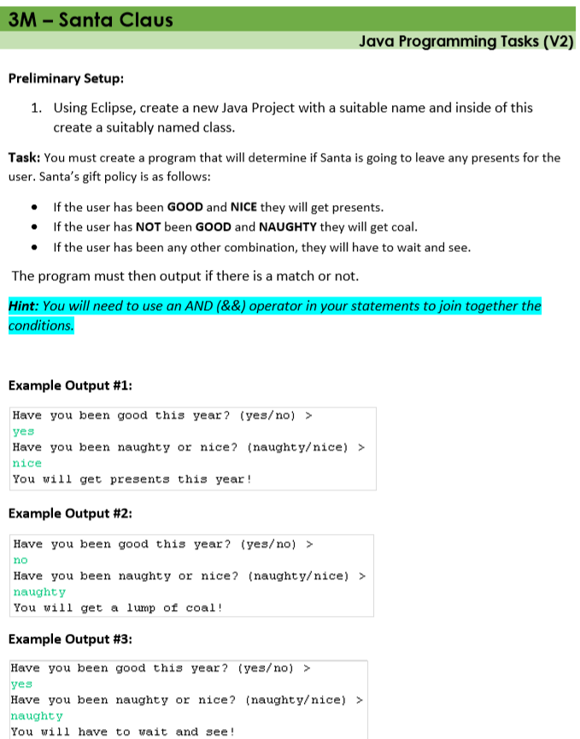

|  |
| --- |
| **Notes:**  **SUBMISSION: Paste your code into the next row along with the ‘**output’ **as a printscreen/screenshot** |
| **CODE**  (this is the actual program code including the main method) |
| **OUTPUT**  (this is the result of running your code) |
| **Reflections**  *What problems did you have in producing this solution?*  *How could you improve for next time?*  *Overall, how difficult was it? (fill the boxes with colour)*  EASY VERY DIFFICULT   |  |  |  |  |  | | --- | --- | --- | --- | --- | | **1** | **2** | **3** | **4** | **5** | |  |  |  |  |  | |

Task 3N Odd or Even

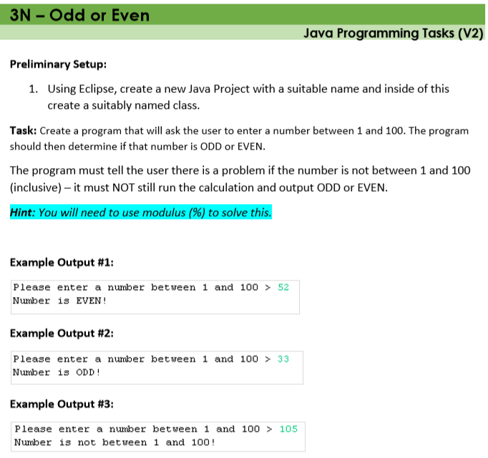

|  |
| --- |
| **Notes:**  **SUBMISSION: Paste your code into the next row along with the ‘**output’ **as a printscreen/screenshot** |
| **CODE**  (this is the actual program code including the main method) |
| **OUTPUT**  (this is the result of running your code) |
| **Reflections**  *What problems did you have in producing this solution?*  *How could you improve for next time?*  *Overall, how difficult was it? (fill the boxes with colour)*  EASY VERY DIFFICULT   |  |  |  |  |  | | --- | --- | --- | --- | --- | | **1** | **2** | **3** | **4** | **5** | |  |  |  |  |  | |

Task 3Q Cinema Age Checker

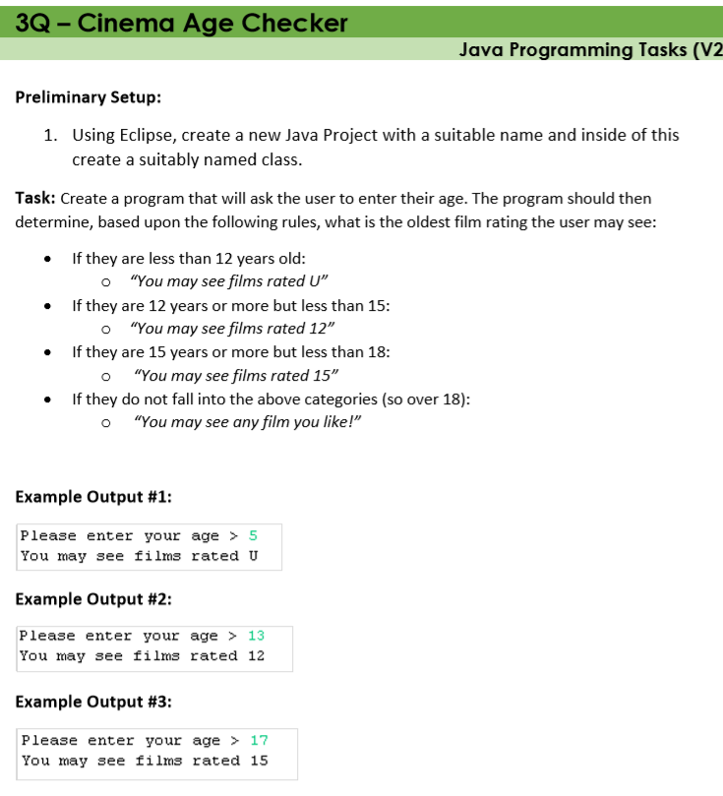

|  |
| --- |
| **Notes:**  **SUBMISSION: Paste your code into the next row along with the ‘**output’ **as a printscreen/screenshot** |
| **CODE**  (this is the actual program code including the main method) |
| **OUTPUT**  (this is the result of running your code) |
| **Reflections**  *What problems did you have in producing this solution?*  *How could you improve for next time?*  *Overall, how difficult was it? (fill the boxes with colour)*  EASY VERY DIFFICULT   |  |  |  |  |  | | --- | --- | --- | --- | --- | | **1** | **2** | **3** | **4** | **5** | |  |  |  |  |  | |

Task 3T Number Selector

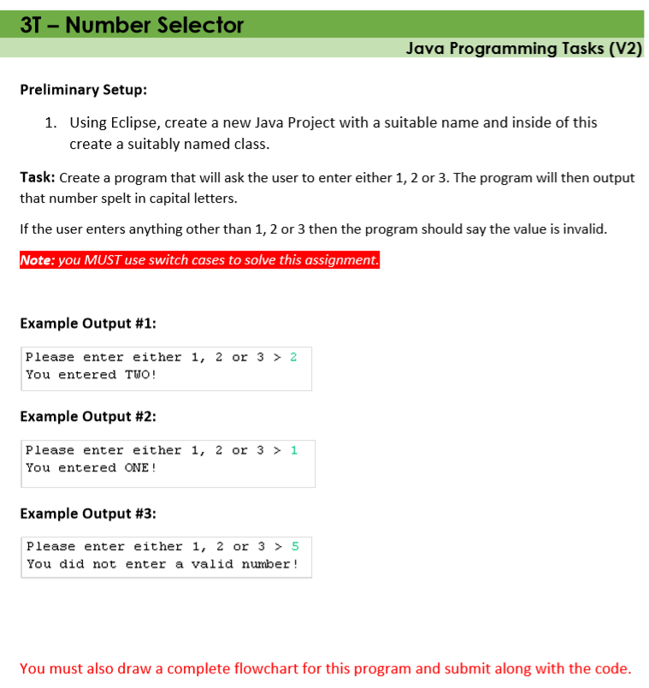

|  |
| --- |
| **Notes:**  **SUBMISSION: Paste your code into the next row along with the ‘**output’ **as a printscreen/screenshot** |
| **CODE**  (this is the actual program code including the main method) |
| **OUTPUT**  (this is the result of running your code)  **Flowchart** |
| **Reflections**  *What problems did you have in producing this solution?*  *How could you improve for next time?*  *Overall, how difficult was it? (fill the boxes with colour)*  EASY VERY DIFFICULT   |  |  |  |  |  | | --- | --- | --- | --- | --- | | **1** | **2** | **3** | **4** | **5** | |  |  |  |  |  | |

Task 3V Quiz Master

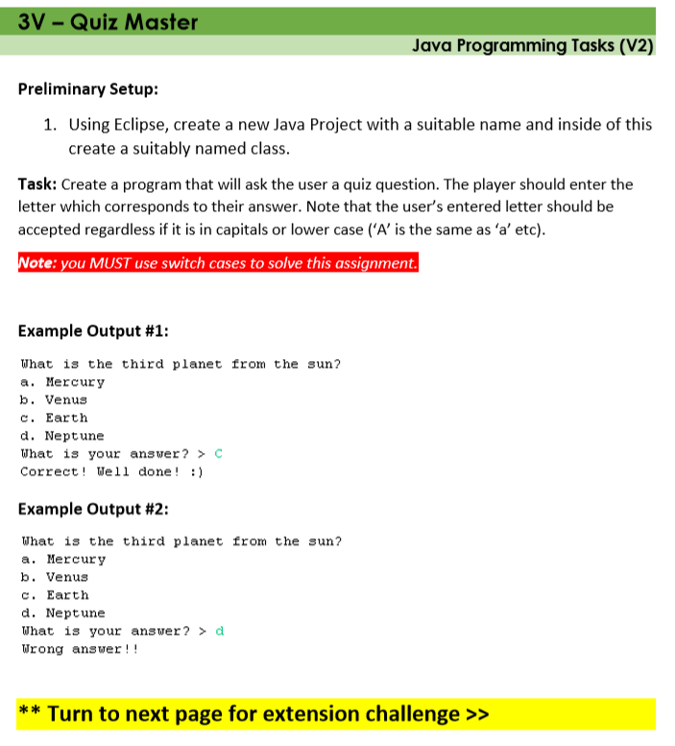

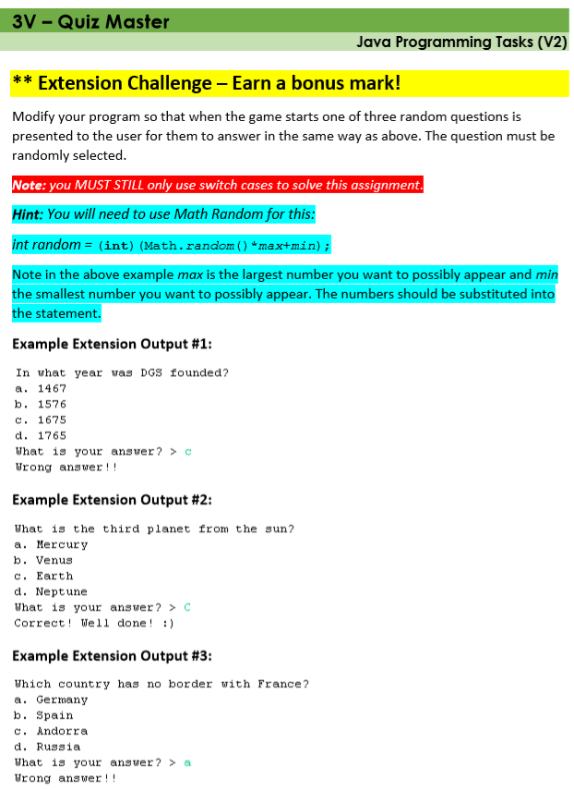

|  |
| --- |
| **Notes:**  **SUBMISSION: Paste your code into the next row along with the ‘**output’ **as a printscreen/screenshot** |
| **CODE**  (this is the actual program code including the main method) |
| **OUTPUT**  (this is the result of running your code) |
| **EXTENSION** |
| **Reflections**  *What problems did you have in producing this solution?*  *How could you improve for next time?*  *Overall, how difficult was it? (fill the boxes with colour)*  EASY VERY DIFFICULT   |  |  |  |  |  | | --- | --- | --- | --- | --- | | **1** | **2** | **3** | **4** | **5** | |  |  |  |  |  | |

Task 3W Case Calc

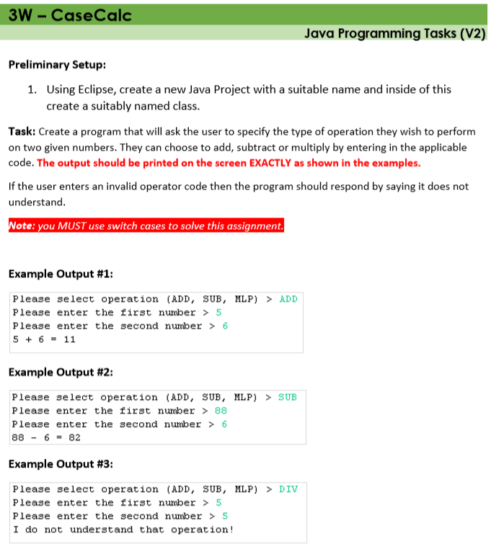

**Extension task is on the next page**

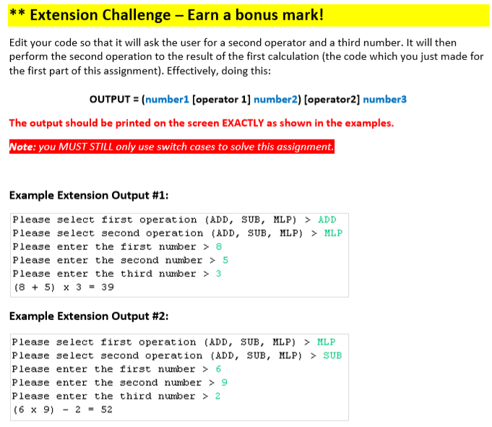

|  |
| --- |
| **Notes:**  **SUBMISSION: Paste your code into the next row along with the ‘**output’ **as a printscreen/screenshot** |
| **CODE**  (this is the actual program code including the main method) |
| **OUTPUT**  (this is the result of running your code) |
| **EXTENSION** |
| **Reflections**  *What problems did you have in producing this solution?*  *How could you improve for next time?*  *Overall, how difficult was it? (fill the boxes with colour)*  EASY VERY DIFFICULT   |  |  |  |  |  | | --- | --- | --- | --- | --- | | **1** | **2** | **3** | **4** | **5** | |  |  |  |  |  | |

Level 4: Iteration (easy-medium)

Task 4 – Repeat after me

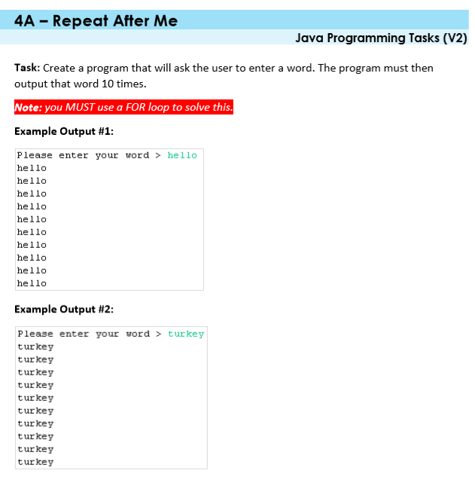

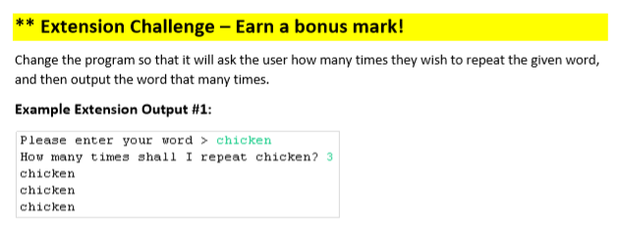

|  |
| --- |
| **Notes:**  **SUBMISSION: Paste your code into the next row along with the ‘**output’ **as a printscreen/screenshot** |
| **CODE**  (this is the actual program code including the main method) |
| **OUTPUT**  (this is the result of running your code) |
| **EXTENSION** |
| **Reflections**  *What problems did you have in producing this solution?*  *How could you improve for next time?*  *Overall, how difficult was it? (fill the boxes with colour)*  EASY VERY DIFFICULT   |  |  |  |  |  | | --- | --- | --- | --- | --- | | **1** | **2** | **3** | **4** | **5** | |  |  |  |  |  | |

Task 4B Spellman

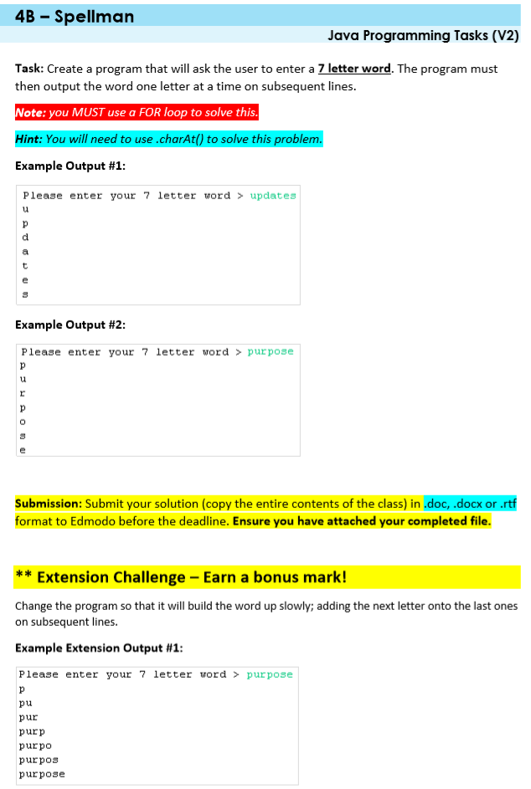

|  |
| --- |
| **Notes:**  **SUBMISSION: Paste your code into the next row along with the ‘**output’ **as a printscreen/screenshot** |
| **CODE**  (this is the actual program code including the main method) |
| **OUTPUT**  (this is the result of running your code) |
| **EXTENSION** |
| **Reflections**  *What problems did you have in producing this solution?*  *How could you improve for next time?*  *Overall, how difficult was it? (fill the boxes with colour)*  EASY VERY DIFFICULT   |  |  |  |  |  | | --- | --- | --- | --- | --- | | **1** | **2** | **3** | **4** | **5** | |  |  |  |  |  | |

Task 4C Alphabet Loop

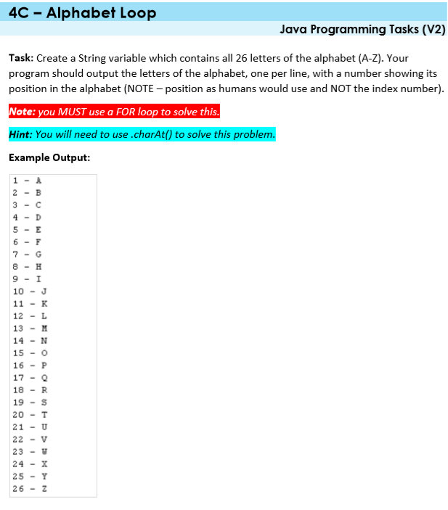

**Extension task is on the next page**

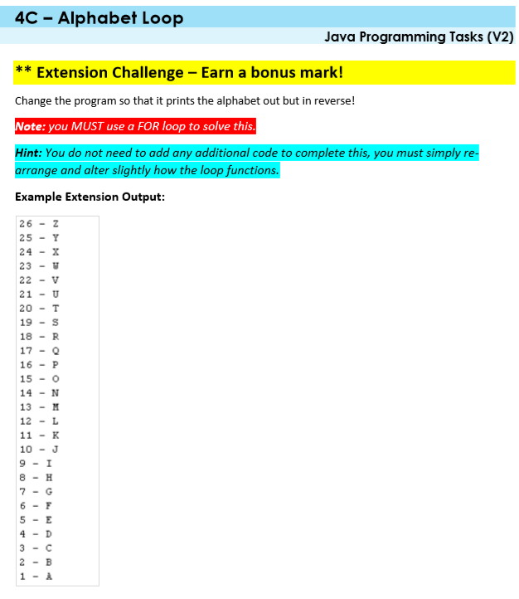

|  |
| --- |
| **Notes:**  **SUBMISSION: Paste your code into the next row along with the ‘**output’ **as a printscreen/screenshot** |
| **CODE**  (this is the actual program code including the main method) |
| **OUTPUT**  (this is the result of running your code) |
| **EXTENSION** |
| **Reflections**  *What problems did you have in producing this solution?*  *How could you improve for next time?*  *Overall, how difficult was it? (fill the boxes with colour)*  EASY VERY DIFFICULT   |  |  |  |  |  | | --- | --- | --- | --- | --- | | **1** | **2** | **3** | **4** | **5** | |  |  |  |  |  | |

Task 4D Doubling Score

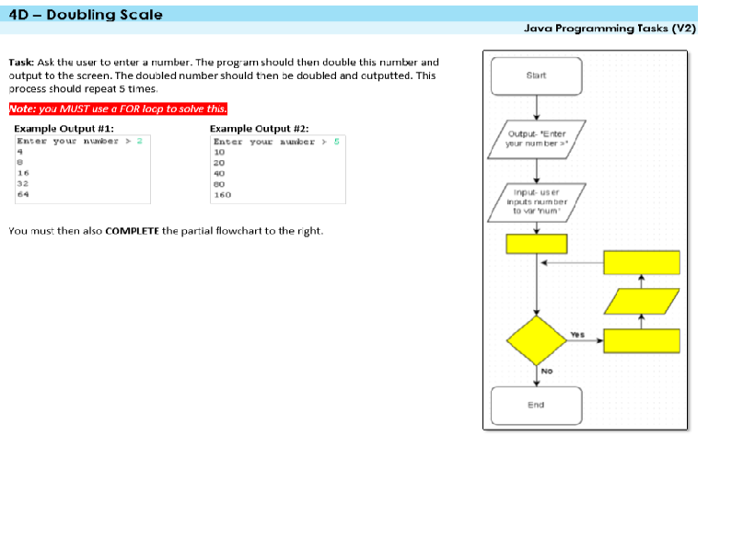

**NOTE: For this solution, a flowchart must also be completed within flowgorithm or your own choice of tool**

|  |
| --- |
| **Notes:**  **SUBMISSION: Paste your code into the next row along with the ‘**output’ **as a printscreen/screenshot** |
| **CODE**  (this is the actual program code including the main method) |
| **OUTPUT**  (this is the result of running your code) |
| Flowchart |
| **Reflections**  *What problems did you have in producing this solution?*  *How could you improve for next time?*  *Overall, how difficult was it? (fill the boxes with colour)*  EASY VERY DIFFICULT   |  |  |  |  |  | | --- | --- | --- | --- | --- | | **1** | **2** | **3** | **4** | **5** | |  |  |  |  |  | |

Task 4E Green Bottles

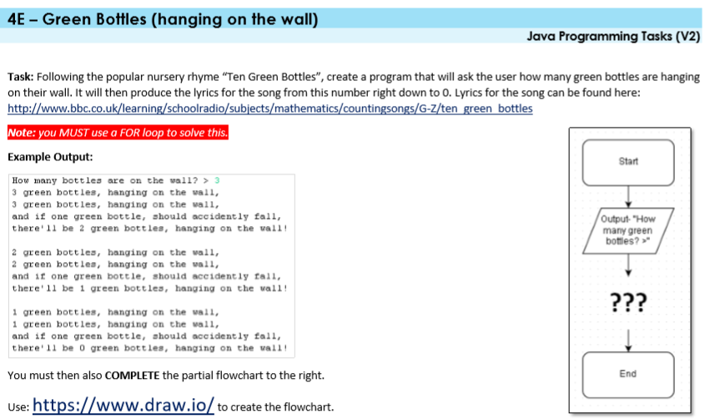

**NOTE: For this solution, a flowchart must also be completed within flowgorithm or your own choice of tool**

|  |
| --- |
| **Notes:**  **SUBMISSION: Paste your code into the next row along with the ‘**output’ **as a printscreen/screenshot** |
| **CODE**  (this is the actual program code including the main method) |
| **OUTPUT**  (this is the result of running your code) |
| **Flowchart** |
| **Reflections**  *What problems did you have in producing this solution?*  *How could you improve for next time?*  *Overall, how difficult was it? (fill the boxes with colour)*  EASY VERY DIFFICULT   |  |  |  |  |  | | --- | --- | --- | --- | --- | | **1** | **2** | **3** | **4** | **5** | |  |  |  |  |  | |

Task 4F Factors

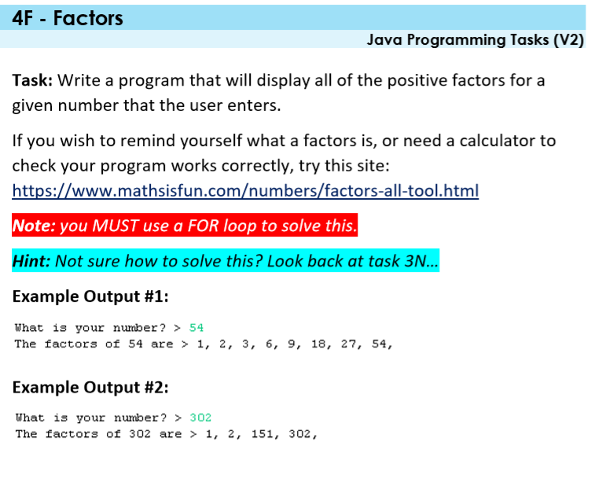

|  |
| --- |
| **Notes:**  **SUBMISSION: Paste your code into the next row along with the ‘**output’ **as a printscreen/screenshot** |
| **CODE**  (this is the actual program code including the main method) |
| **OUTPUT**  (this is the result of running your code) |
| **EXTENSION** |
| **Reflections**  *What problems did you have in producing this solution?*  *How could you improve for next time?*  *Overall, how difficult was it? (fill the boxes with colour)*  EASY VERY DIFFICULT   |  |  |  |  |  | | --- | --- | --- | --- | --- | | **1** | **2** | **3** | **4** | **5** | |  |  |  |  |  | |

Task 4G Loops with numbers

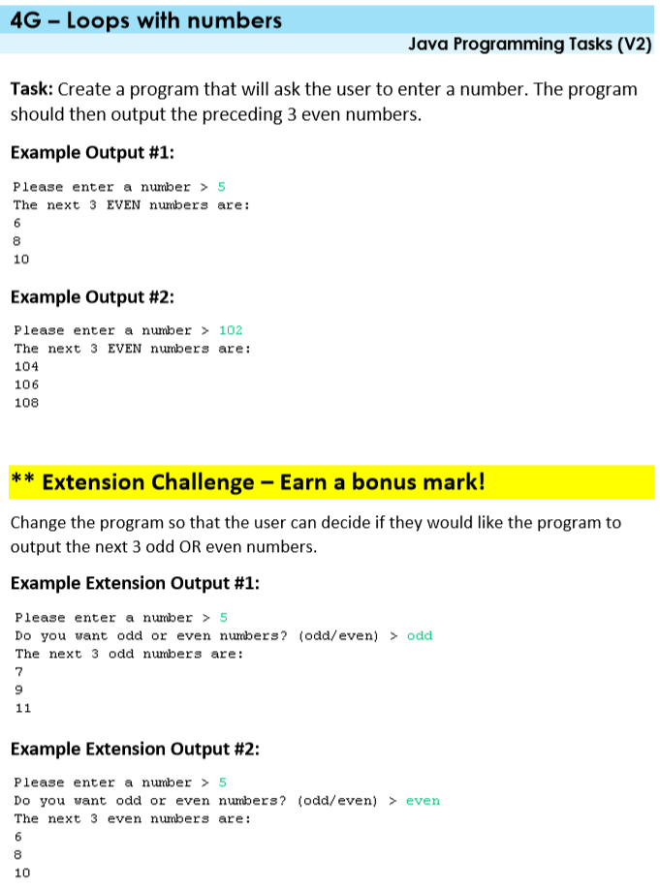

|  |
| --- |
| **Notes:**  **SUBMISSION: Paste your code into the next row along with the ‘**output’ **as a printscreen/screenshot** |
| **CODE**  (this is the actual program code including the main method) |
| **OUTPUT**  (this is the result of running your code) |
| **EXTENSION** |
| **Reflections**  *What problems did you have in producing this solution?*  *How could you improve for next time?*  *Overall, how difficult was it? (fill the boxes with colour)*  EASY VERY DIFFICULT   |  |  |  |  |  | | --- | --- | --- | --- | --- | | **1** | **2** | **3** | **4** | **5** | |  |  |  |  |  | |

Task 4H Block Maker

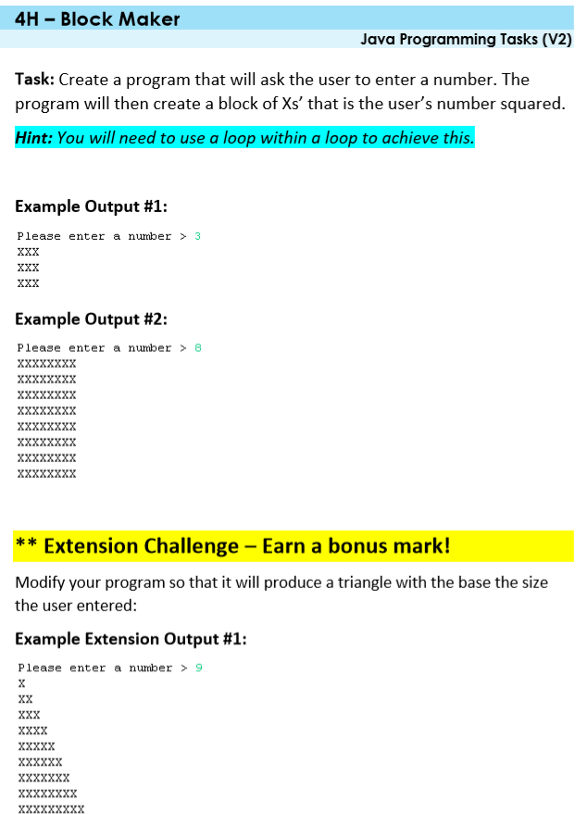

|  |
| --- |
| **Notes:**  **SUBMISSION: Paste your code into the next row along with the ‘**output’ **as a printscreen/screenshot** |
| **CODE**  (this is the actual program code including the main method) |
| **OUTPUT**  (this is the result of running your code) |
| **EXTENSION** |
| **Reflections**  *What problems did you have in producing this solution?*  *How could you improve for next time?*  *Overall, how difficult was it? (fill the boxes with colour)*  EASY VERY DIFFICULT   |  |  |  |  |  | | --- | --- | --- | --- | --- | | **1** | **2** | **3** | **4** | **5** | |  |  |  |  |  | |

Task 4I Word Pyramid

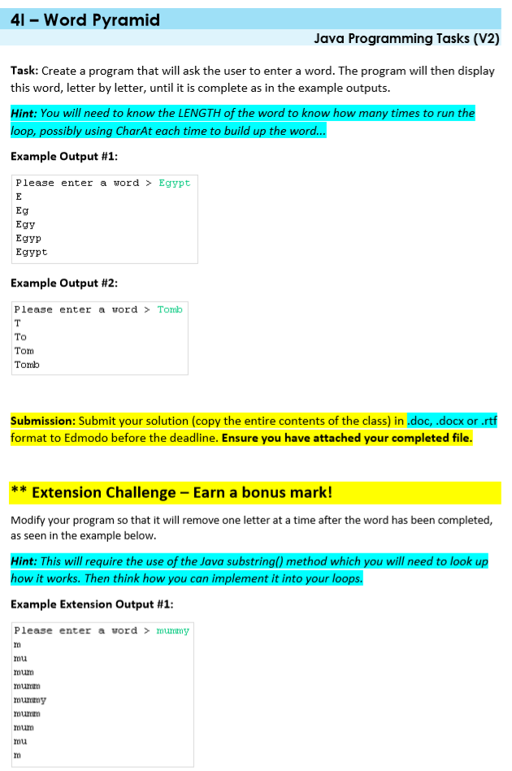

|  |
| --- |
| **Notes:**  **SUBMISSION: Paste your code into the next row along with the ‘**output’ **as a printscreen/screenshot** |
| **CODE**  (this is the actual program code including the main method) |
| **OUTPUT**  (this is the result of running your code) |
| **EXTENSION** |
| **Reflections**  *What problems did you have in producing this solution?*  *How could you improve for next time?*  *Overall, how difficult was it? (fill the boxes with colour)*  EASY VERY DIFFICULT   |  |  |  |  |  | | --- | --- | --- | --- | --- | | **1** | **2** | **3** | **4** | **5** | |  |  |  |  |  | |

Task 4J Plus Me

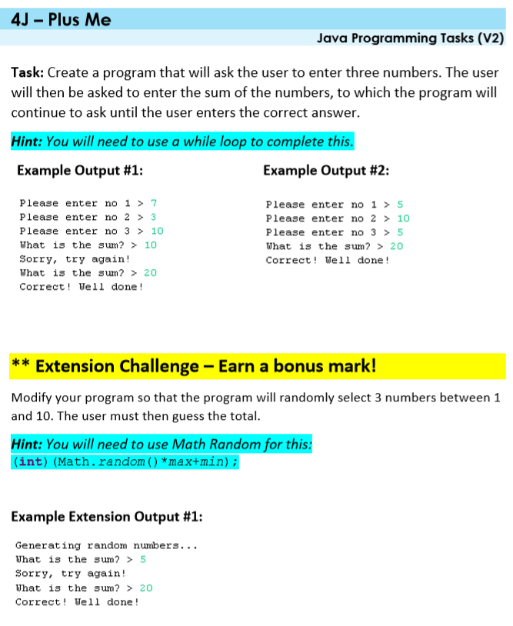

|  |
| --- |
| **Notes:**  **SUBMISSION: Paste your code into the next row along with the ‘**output’ **as a printscreen/screenshot** |
| **CODE**  (this is the actual program code including the main method) |
| **OUTPUT**  (this is the result of running your code) |
| **EXTENSION** |
| **Reflections**  *What problems did you have in producing this solution?*  *How could you improve for next time?*  *Overall, how difficult was it? (fill the boxes with colour)*  EASY VERY DIFFICULT   |  |  |  |  |  | | --- | --- | --- | --- | --- | | **1** | **2** | **3** | **4** | **5** | |  |  |  |  |  | |

Task 4K Word Size Checker

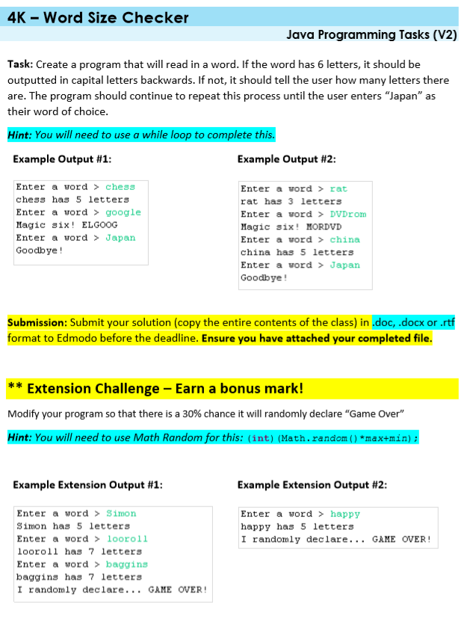

|  |
| --- |
| **Notes:**  **SUBMISSION: Paste your code into the next row along with the ‘**output’ **as a printscreen/screenshot** |
| **CODE**  (this is the actual program code including the main method) |
| **OUTPUT**  (this is the result of running your code) |
| **EXTENSION** |
| **Reflections**  *What problems did you have in producing this solution?*  *How could you improve for next time?*  *Overall, how difficult was it? (fill the boxes with colour)*  EASY VERY DIFFICULT   |  |  |  |  |  | | --- | --- | --- | --- | --- | | **1** | **2** | **3** | **4** | **5** | |  |  |  |  |  | |

Task 4L While Calc

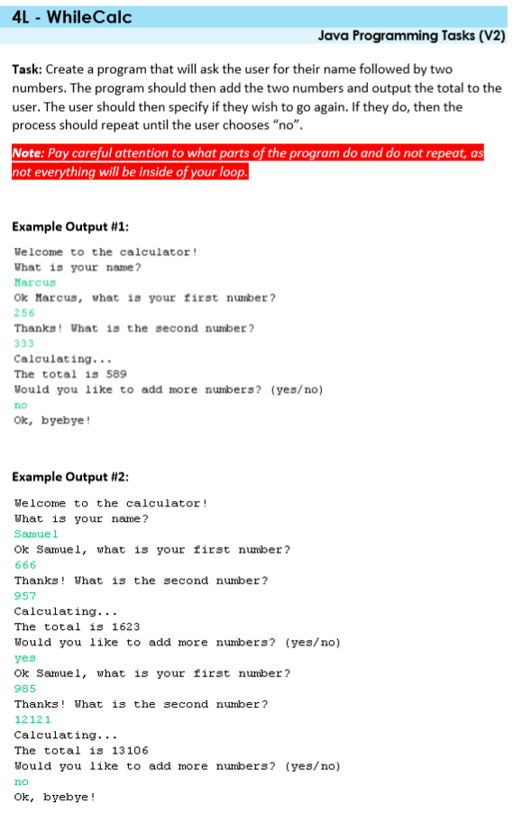

**Extension task is on the next page**

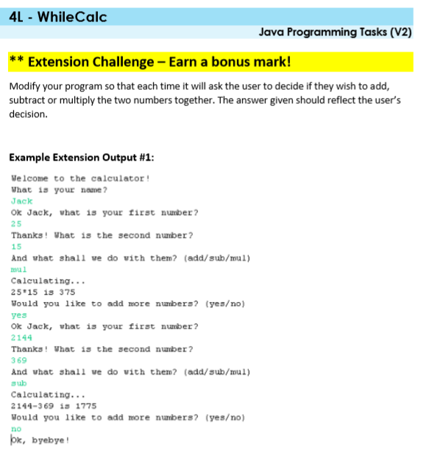

|  |
| --- |
| **Notes:**  **SUBMISSION: Paste your code into the next row along with the ‘**output’ **as a printscreen/screenshot** |
| **CODE**  (this is the actual program code including the main method) |
| **OUTPUT**  (this is the result of running your code) |
| **EXTENSION** |
| **Reflections**  *What problems did you have in producing this solution?*  *How could you improve for next time?*  *Overall, how difficult was it? (fill the boxes with colour)*  EASY VERY DIFFICULT   |  |  |  |  |  | | --- | --- | --- | --- | --- | | **1** | **2** | **3** | **4** | **5** | |  |  |  |  |  | |

Task 4M Block Maker 2

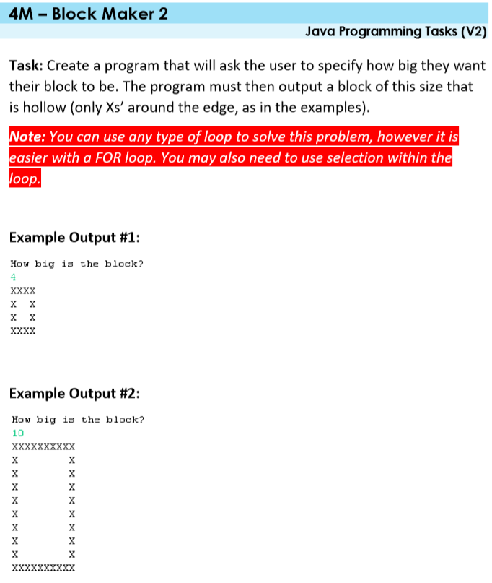

|  |
| --- |
| **Notes:**  **SUBMISSION: Paste your code into the next row along with the ‘**output’ **as a printscreen/screenshot** |
| **CODE**  (this is the actual program code including the main method) |
| **OUTPUT**  (this is the result of running your code) |
| **EXTENSION** |
| **Reflections**  *What problems did you have in producing this solution?*  *How could you improve for next time?*  *Overall, how difficult was it? (fill the boxes with colour)*  EASY VERY DIFFICULT   |  |  |  |  |  | | --- | --- | --- | --- | --- | | **1** | **2** | **3** | **4** | **5** | |  |  |  |  |  | |

Level 5: Algorithmic Thinking (medium)

Task 5B Biggest Number

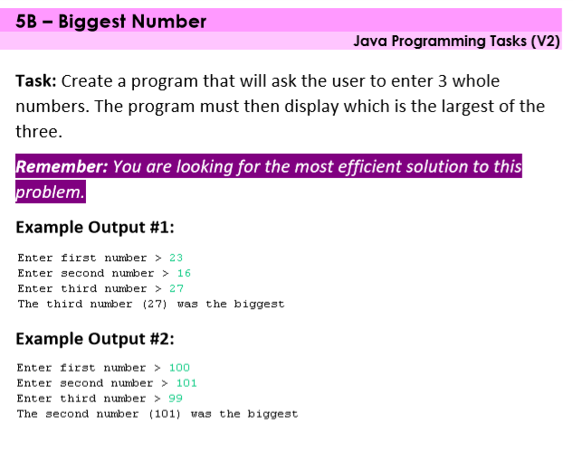

|  |
| --- |
| **Notes:**  **SUBMISSION: Paste your code into the next row along with the ‘**output’ **as a printscreen/screenshot** |
| **CODE**  (this is the actual program code including the main method) |
| **OUTPUT**  (this is the result of running your code) |
| **EXTENSION** |
| **Reflections**  *What problems did you have in producing this solution?*  *How could you improve for next time?*  *Overall, how difficult was it? (fill the boxes with colour)*  EASY VERY DIFFICULT   |  |  |  |  |  | | --- | --- | --- | --- | --- | | **1** | **2** | **3** | **4** | **5** | |  |  |  |  |  | |

Task 5C Maths Trainer

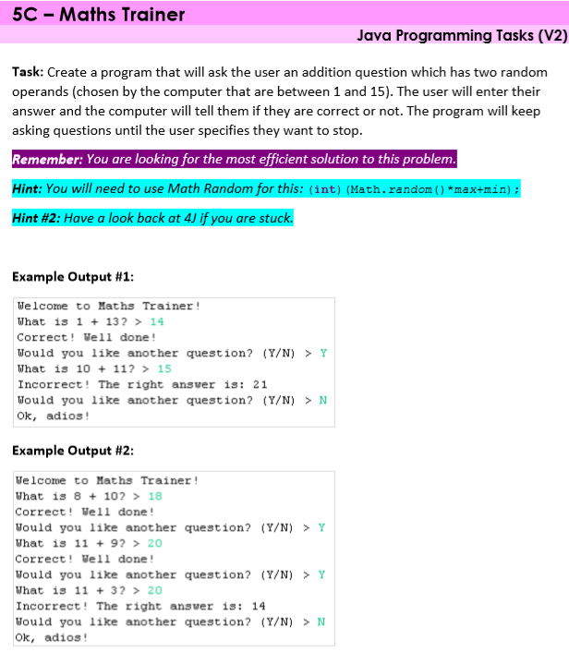

|  |
| --- |
| **Notes:**  **SUBMISSION: Paste your code into the next row along with the ‘**output’ **as a printscreen/screenshot** |
| **CODE**  (this is the actual program code including the main method) |
| **OUTPUT**  (this is the result of running your code) |
| **EXTENSION** |
| **Reflections**  *What problems did you have in producing this solution?*  *How could you improve for next time?*  *Overall, how difficult was it? (fill the boxes with colour)*  EASY VERY DIFFICULT   |  |  |  |  |  | | --- | --- | --- | --- | --- | | **1** | **2** | **3** | **4** | **5** | |  |  |  |  |  | |

Task 5E Lock Picker

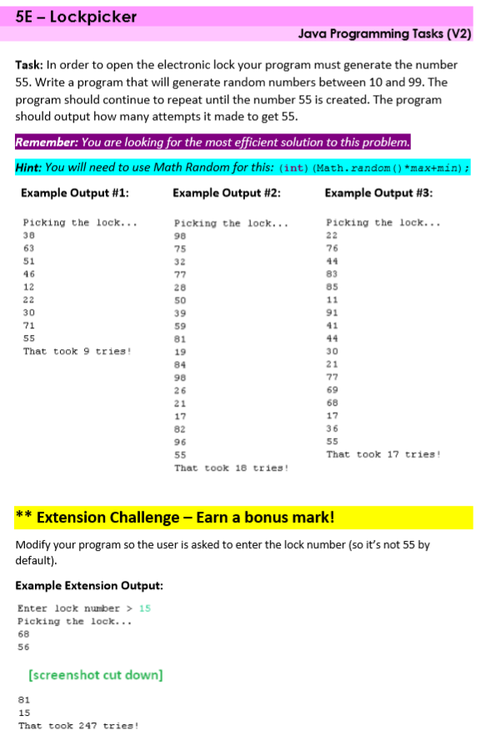

|  |
| --- |
| **Notes:**  **SUBMISSION: Paste your code into the next row along with the ‘**output’ **as a printscreen/screenshot** |
| **CODE**  (this is the actual program code including the main method) |
| **OUTPUT**  (this is the result of running your code) |
| **EXTENSION** |
| **Reflections**  *What problems did you have in producing this solution?*  *How could you improve for next time?*  *Overall, how difficult was it? (fill the boxes with colour)*  EASY VERY DIFFICULT   |  |  |  |  |  | | --- | --- | --- | --- | --- | | **1** | **2** | **3** | **4** | **5** | |  |  |  |  |  | |

Task 5F Season Checker

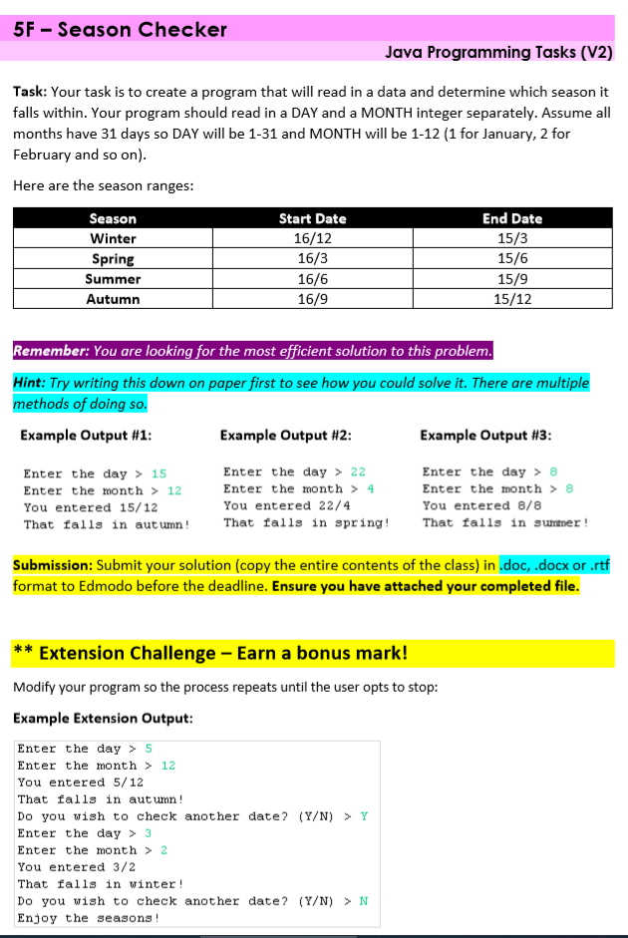

|  |
| --- |
| **Notes:**  **SUBMISSION: Paste your code into the next row along with the ‘**output’ **as a printscreen/screenshot** |
| **CODE**  (this is the actual program code including the main method) |
| **OUTPUT**  (this is the result of running your code) |
| **EXTENSION** |
| **Reflections**  *What problems did you have in producing this solution?*  *How could you improve for next time?*  *Overall, how difficult was it? (fill the boxes with colour)*  EASY VERY DIFFICULT   |  |  |  |  |  | | --- | --- | --- | --- | --- | | **1** | **2** | **3** | **4** | **5** | |  |  |  |  |  | |

Task 5M Name Mixer

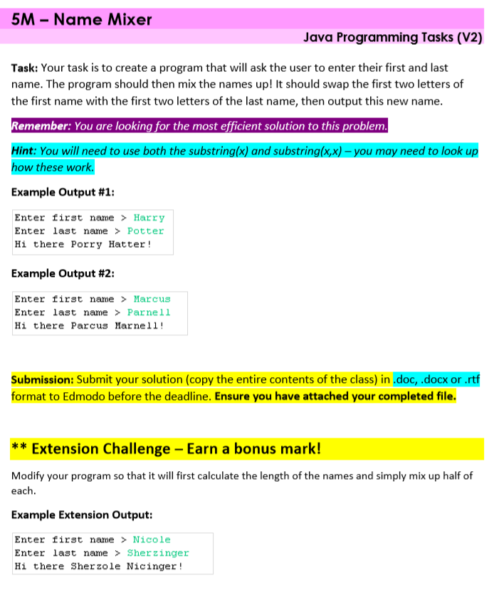

|  |
| --- |
| **Notes:**  **SUBMISSION: Paste your code into the next row along with the ‘**output’ **as a printscreen/screenshot** |
| **CODE**  (this is the actual program code including the main method) |
| **OUTPUT**  (this is the result of running your code) |
| **EXTENSION** |
| **Reflections**  *What problems did you have in producing this solution?*  *How could you improve for next time?*  *Overall, how difficult was it? (fill the boxes with colour)*  EASY VERY DIFFICULT   |  |  |  |  |  | | --- | --- | --- | --- | --- | | **1** | **2** | **3** | **4** | **5** | |  |  |  |  |  | |

Task 5R InCommon

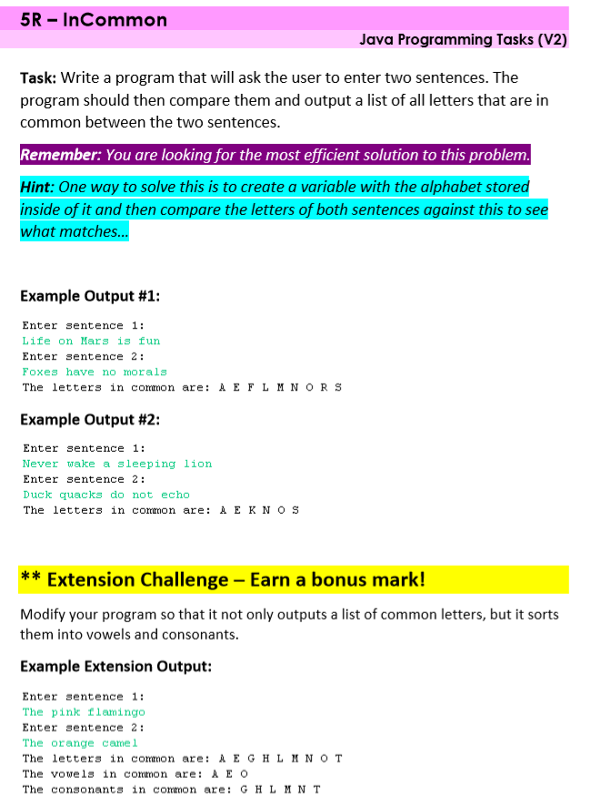

|  |
| --- |
| **Notes:**  **SUBMISSION: Paste your code into the next row along with the ‘**output’ **as a printscreen/screenshot** |
| **CODE**  (this is the actual program code including the main method) |
| **OUTPUT**  (this is the result of running your code) |
| **EXTENSION** |
| **Reflections**  *What problems did you have in producing this solution?*  *How could you improve for next time?*  *Overall, how difficult was it? (fill the boxes with colour)*  EASY VERY DIFFICULT   |  |  |  |  |  | | --- | --- | --- | --- | --- | | **1** | **2** | **3** | **4** | **5** | |  |  |  |  |  | |

Level 6: Arrays

Task 6A Little Boxes

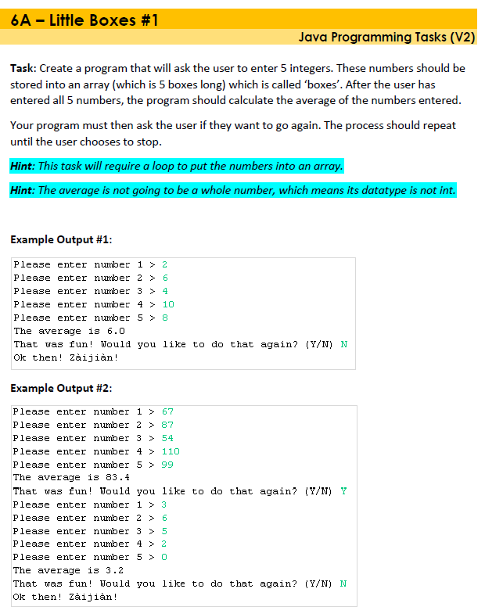

|  |
| --- |
| **Notes:**  **SUBMISSION: Paste your code into the next row along with the ‘**output’ **as a printscreen/screenshot** |
| **CODE**  (this is the actual program code including the main method) |
| **OUTPUT**  (this is the result of running your code) |
| **EXTENSION** |
| **Reflections**  *What problems did you have in producing this solution?*  *How could you improve for next time?*  *Overall, how difficult was it? (fill the boxes with colour)*  EASY VERY DIFFICULT   |  |  |  |  |  | | --- | --- | --- | --- | --- | | **1** | **2** | **3** | **4** | **5** | |  |  |  |  |  | |

Task 6A Little Boxes

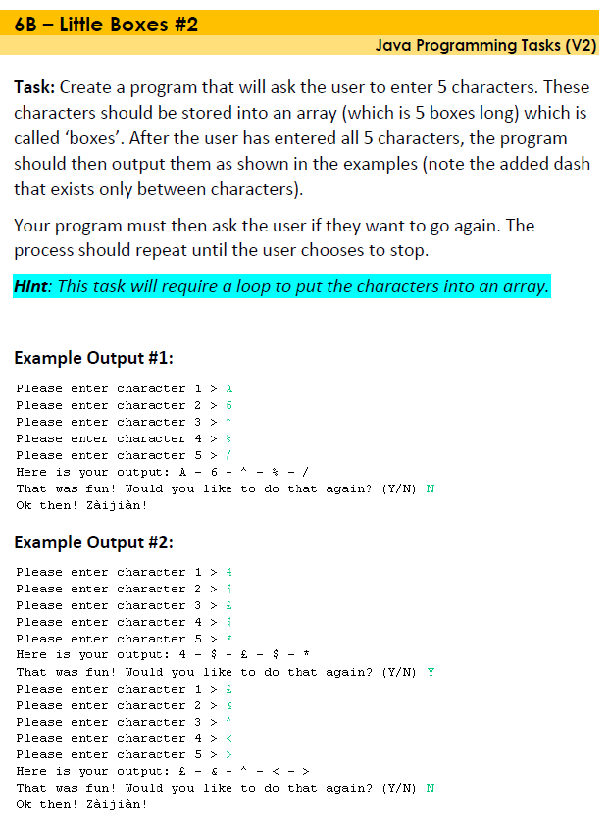

|  |
| --- |
| **Notes:**  **SUBMISSION: Paste your code into the next row along with the ‘**output’ **as a printscreen/screenshot** |
| **CODE**  (this is the actual program code including the main method) |
| **OUTPUT**  (this is the result of running your code) |
| **EXTENSION** |
| **Reflections**  *What problems did you have in producing this solution?*  *How could you improve for next time?*  *Overall, how difficult was it? (fill the boxes with colour)*  EASY VERY DIFFICULT   |  |  |  |  |  | | --- | --- | --- | --- | --- | | **1** | **2** | **3** | **4** | **5** | |  |  |  |  |  | |

Task 6C Number Hunt

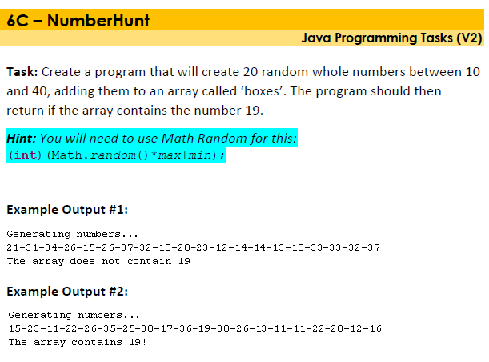

|  |
| --- |
| **Notes:**  **SUBMISSION: Paste your code into the next row along with the ‘**output’ **as a printscreen/screenshot** |
| **CODE**  (this is the actual program code including the main method) |
| **OUTPUT**  (this is the result of running your code) |
| **EXTENSION** |
| **Reflections**  *What problems did you have in producing this solution?*  *How could you improve for next time?*  *Overall, how difficult was it? (fill the boxes with colour)*  EASY VERY DIFFICULT   |  |  |  |  |  | | --- | --- | --- | --- | --- | | **1** | **2** | **3** | **4** | **5** | |  |  |  |  |  | |

Task 6D Backward Boxes

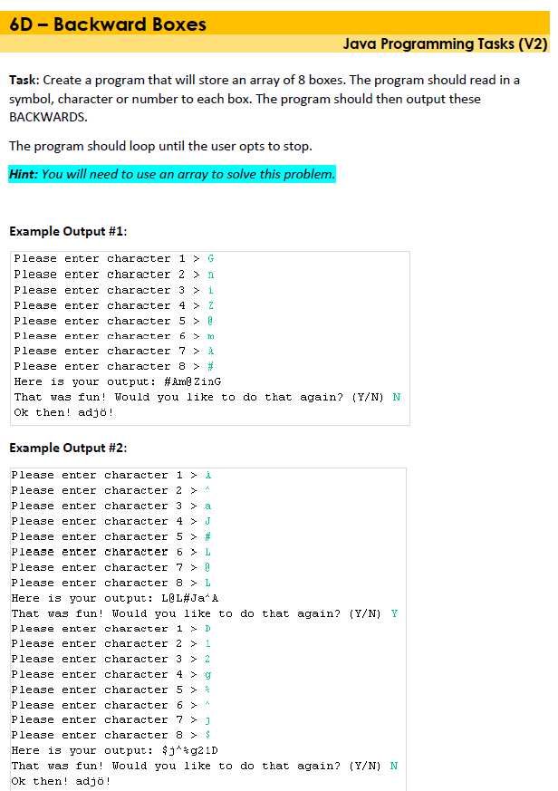

|  |
| --- |
| **Notes:**  **SUBMISSION: Paste your code into the next row along with the ‘**output’ **as a printscreen/screenshot** |
| **CODE**  (this is the actual program code including the main method) |
| **OUTPUT**  (this is the result of running your code) |
| **EXTENSION** |
| **Reflections**  *What problems did you have in producing this solution?*  *How could you improve for next time?*  *Overall, how difficult was it? (fill the boxes with colour)*  EASY VERY DIFFICULT   |  |  |  |  |  | | --- | --- | --- | --- | --- | | **1** | **2** | **3** | **4** | **5** | |  |  |  |  |  | |

Task 6F Array Averages

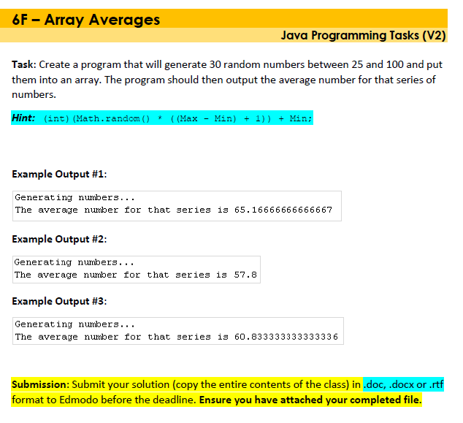

|  |
| --- |
| **Notes:**  **SUBMISSION: Paste your code into the next row along with the ‘**output’ **as a printscreen/screenshot** |
| **CODE**  (this is the actual program code including the main method) |
| **OUTPUT**  (this is the result of running your code) |
| **EXTENSION** |
| **Reflections**  *What problems did you have in producing this solution?*  *How could you improve for next time?*  *Overall, how difficult was it? (fill the boxes with colour)*  EASY VERY DIFFICULT   |  |  |  |  |  | | --- | --- | --- | --- | --- | | **1** | **2** | **3** | **4** | **5** | |  |  |  |  |  | |

Task 6G Array Min

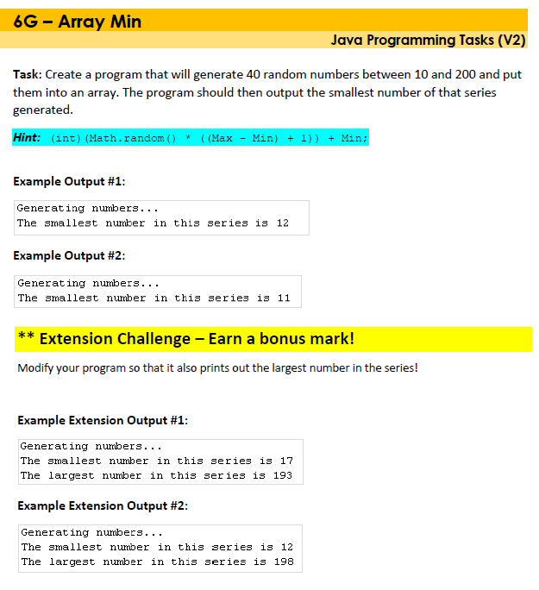

|  |
| --- |
| **Notes:**  **SUBMISSION: Paste your code into the next row along with the ‘**output’ **as a printscreen/screenshot** |
| **CODE**  (this is the actual program code including the main method) |
| **OUTPUT**  (this is the result of running your code) |
| **EXTENSION** |
| **Reflections**  *What problems did you have in producing this solution?*  *How could you improve for next time?*  *Overall, how difficult was it? (fill the boxes with colour)*  EASY VERY DIFFICULT   |  |  |  |  |  | | --- | --- | --- | --- | --- | | **1** | **2** | **3** | **4** | **5** | |  |  |  |  |  | |

Task 6A Little Boxes

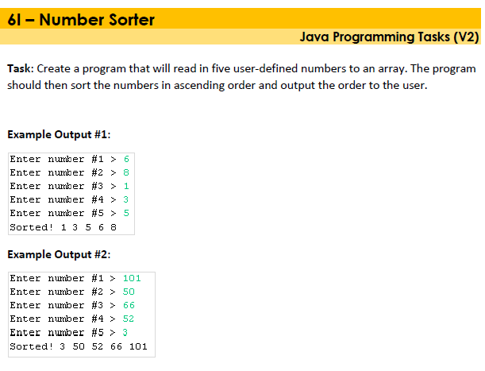

|  |
| --- |
| **Notes:**  **SUBMISSION: Paste your code into the next row along with the ‘**output’ **as a printscreen/screenshot** |
| **CODE**  (this is the actual program code including the main method) |
| **OUTPUT**  (this is the result of running your code) |
| **EXTENSION** |
| **Reflections**  *What problems did you have in producing this solution?*  *How could you improve for next time?*  *Overall, how difficult was it? (fill the boxes with colour)*  EASY VERY DIFFICULT   |  |  |  |  |  | | --- | --- | --- | --- | --- | | **1** | **2** | **3** | **4** | **5** | |  |  |  |  |  | |

Task 6N Letter Sorter

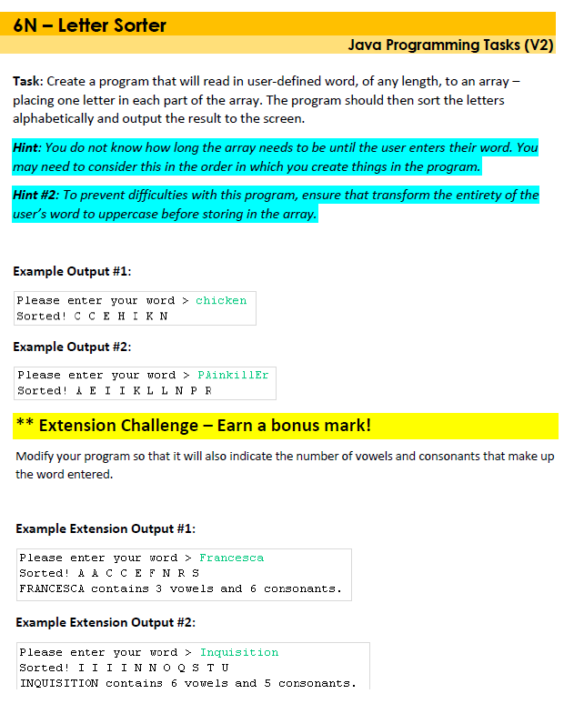

|  |
| --- |
| **Notes:**  **SUBMISSION: Paste your code into the next row along with the ‘**output’ **as a printscreen/screenshot** |
| **CODE**  (this is the actual program code including the main method) |
| **OUTPUT**  (this is the result of running your code) |
| **EXTENSION** |
| **Reflections**  *What problems did you have in producing this solution?*  *How could you improve for next time?*  *Overall, how difficult was it? (fill the boxes with colour)*  EASY VERY DIFFICULT   |  |  |  |  |  | | --- | --- | --- | --- | --- | | **1** | **2** | **3** | **4** | **5** | |  |  |  |  |  | |

Task 6O Super Sorter

